Inner Radius of a Cylinder
# Source: AI Source: Provided by: [Data Path: Persons Table -> ID Column: 1, Name_En Column: Motasem Essam] -> From: [ChatGPT] on [7/25/2026]
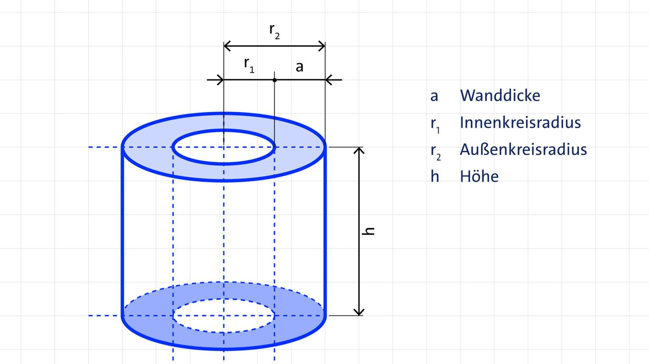
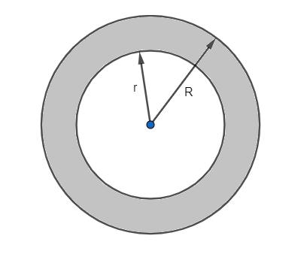
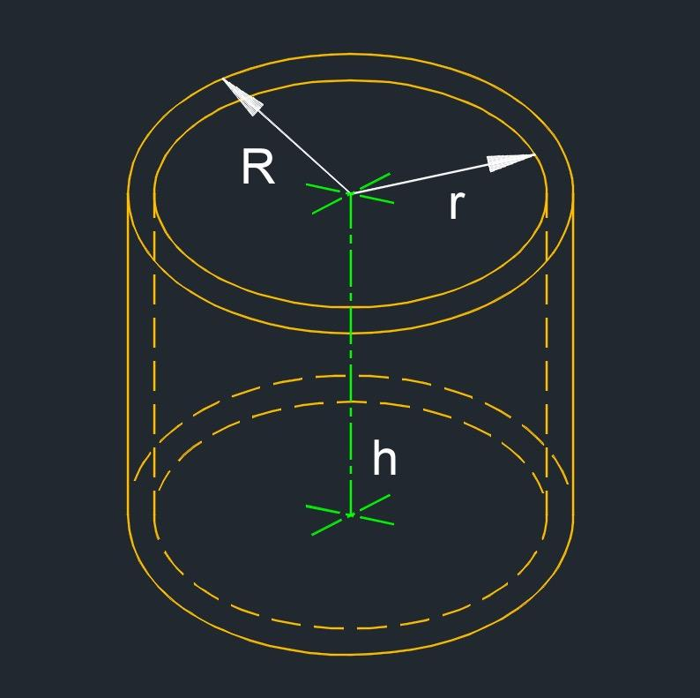

Definition
# Source: AI Source: Provided by: [Data Path: Persons Table -> ID Column: 1, Name_En Column: Motasem Essam] -> From: [ChatGPT] on [7/25/2026]
The inner radius of a hollow cylinder is the perpendicular distance from the cylinder's central axis to the inner circular boundary of its hollow region.
It is commonly represented by $r$, $r_{i}$, or $R_{\text{inner}}$. It describes the size of the cylinder's internal opening.
For a hollow cylindrical pipe, the inner radius determines the radius of the space through which a fluid, object, or other material can pass.

Simple Definition
# Source: AI Source: Provided by: [Data Path: Persons Table -> ID Column: 1, Name_En Column: Motasem Essam] -> From: [ChatGPT] on [7/25/2026]
The inner radius is the distance from the center of a hollow cylinder to the inside edge of its circular opening.

Geometric Representation
# Source: AI Source: Provided by: [Data Path: Persons Table -> ID Column: 1, Name_En Column: Motasem Essam] -> From: [ChatGPT] on [7/25/2026]
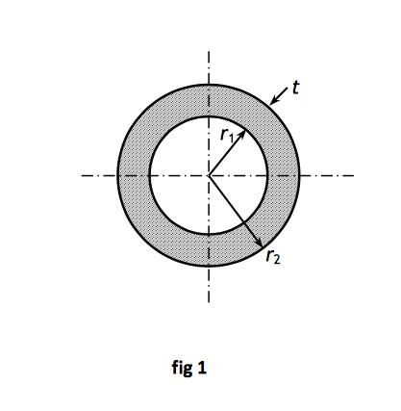
A hollow cylinder has two circular boundaries when viewed in cross-section:
- Inner circular boundary: surrounds the hollow opening.
- Outer circular boundary: forms the external edge of the cylinder.
- Inner radius ($r_{i}$): extends from the center to the inner boundary.
- Outer radius ($R$): extends from the center to the outer boundary.
- Wall thickness ($t$): the distance between the inner and outer boundaries.
The inner radius is always smaller than the outer radius for a cylinder with a positive wall thickness.
$$0<r_{i}<R$$

Related Measurements
# Source: AI Source: Provided by: [Data Path: Persons Table -> ID Column: 1, Name_En Column: Motasem Essam] -> From: [ChatGPT] on [7/25/2026]
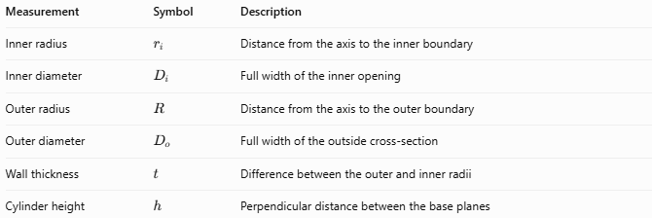
Measurement | Symbol | Description
Inner radius | $$r_{i}$$ | Distance from the axis to the inner boundary
Inner diameter | $$D_{i}$$ | Full width of the inner opening
Outer radius | $$R$$ | Distance from the axis to the outer boundary
Outer diameter | $$D_{o}$$ | Full width of the outside cross-section
Wall thickness | $$t$$ | Difference between the outer and inner radii
Cylinder height | $$h$$ | Perpendicular distance between the base planes

Mathematical Formulas

Inner Radius from Inner Diameter
# Source: AI Source: Provided by: [Data Path: Persons Table -> ID Column: 1, Name_En Column: Motasem Essam] -> From: [ChatGPT] on [7/25/2026]
The inner diameter is twice the inner radius.
$$\boxed{r_{i}=\frac{D_{i}}{2}}$$
Therefore,
$$\boxed{D_{i}=2r_{i}}$$

Inner Radius from Outer Radius and Wall Thickness
# Source: AI Source: Provided by: [Data Path: Persons Table -> ID Column: 1, Name_En Column: Motasem Essam] -> From: [ChatGPT] on [7/25/2026]
The wall thickness equals the difference between the outer and inner radii.
$$t=R-r_{i}$$
Rearranging gives:
$$\boxed{r_{i}=R-t}$$

Inner Radius from Inner Circumference
# Source: AI Source: Provided by: [Data Path: Persons Table -> ID Column: 1, Name_En Column: Motasem Essam] -> From: [ChatGPT] on [7/25/2026]
The circumference of the inner circular boundary is:
$$C_{i}=2πr_{i}$$
Therefore,
$$\boxed{r_{i}=\frac{C_{i}}{2π}}$$

Inner Radius from the Area of the Opening
# Source: AI Source: Provided by: [Data Path: Persons Table -> ID Column: 1, Name_En Column: Motasem Essam] -> From: [ChatGPT] on [7/25/2026]
The area of the circular opening is:
$$A_{i}=πr_{i}^{2}$$
Therefore,
$$\boxed{r_{i}=\sqrt{\frac{A_{i}}{π}}}$$
Here, $A_{i}$ refers to the area of the hollow opening, not the cross-sectional area of the cylinder's material.

Inner Radius from Hollow Cylinder Volume
# Source: AI Source: Provided by: [Data Path: Persons Table -> ID Column: 1, Name_En Column: Motasem Essam] -> From: [ChatGPT] on [7/25/2026]
For a hollow cylinder, the volume of the cylindrical material is:
$$V=πh\left(R^{2}-r_{i}^{2}\right)$$
Rearranging to find the inner radius:
$$\boxed{r_{i}=\sqrt{R^{2}-\frac{V}{πh}}}$$
This formula applies when the outer radius, height, and material volume are known.

Worked Examples
# Source: AI Source: Provided by: [Data Path: Persons Table -> ID Column: 1, Name_En Column: Motasem Essam] -> From: [ChatGPT] on [7/25/2026]
Example 1: Finding the inner radius from diameter
Given:
- Inner diameter: $D_{i}=16\text{ cm}$
Solution:
$$r_{i}=\frac{D_{i}}{2}=\frac{16}{2}$$
$$\boxed{r_{i}=8\text{ cm}}$$
Example 2: Finding the inner radius from wall thickness
Given:
- Outer radius: $R=12\text{ mm}$
- Wall thickness: $t=3\text{ mm}$
Solution:
$$r_{i}=R-t=12-3$$
$$\boxed{r_{i}=9\text{ mm}}$$
Example 3: Finding the inner radius from circumference
Given:
- Inner circumference: $C_{i}=20π\text{ cm}$
Solution:
$$r_{i}=\frac{C_{i}}{2π}=\frac{20π}{2π}$$
$$\boxed{r_{i}=10\text{ cm}}$$
Example 4: Finding the inner radius from material volume
Given:
- Outer radius: $R=5\text{ cm}$
- Height: $h=8\text{ cm}$
- Material volume: $V=128π{\text{ cm}}^{3}$
Solution:
$$r_{i}=\sqrt{R^{2}-\frac{V}{πh}}$$
$$r_{i}=\sqrt{25-\frac{128π}{8π}}=\sqrt{25-16}$$
$$\boxed{r_{i}=3\text{ cm}}$$

Applications
# Source: AI Source: Provided by: [Data Path: Persons Table -> ID Column: 1, Name_En Column: Motasem Essam] -> From: [ChatGPT] on [7/25/2026]
- Pipes and plumbing: determines the opening available for water or gas flow.
- Mechanical engineering: specifies the bore of cylindrical components.
- Hollow shafts: describes the radius of the central hollow region.
- Manufacturing: helps determine wall thickness and material requirements.
- Fluid mechanics: contributes to calculations involving flow area and fluid velocity.
For example, the cross-sectional area available for fluid flow through a circular pipe is:
$$\boxed{A_{\text{opening}}=πr_{i}^{2}}$$

Comparison with Related Concepts
# Source: AI Source: Provided by: [Data Path: Persons Table -> ID Column: 1, Name_En Column: Motasem Essam] -> From: [ChatGPT] on [7/25/2026]
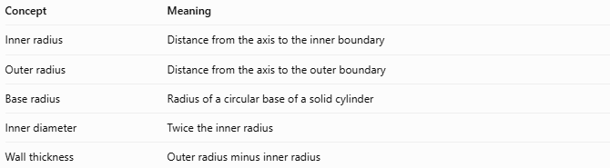
Concept | Meaning
Inner radius | Distance from the axis to the inner boundary
Outer radius | Distance from the axis to the outer boundary
Base radius | Radius of a circular base of a solid cylinder
Inner diameter | Twice the inner radius
Wall thickness | Outer radius minus inner radius
Important distinction: A solid cylinder has no hollow region, so it does not have an inner radius in the usual geometric sense. Its ordinary radius measures the distance from the axis to its external circular boundary.

Key Characteristics
# Source: AI Source: Provided by: [Data Path: Persons Table -> ID Column: 1, Name_En Column: Motasem Essam] -> From: [ChatGPT] on [7/25/2026]
- The inner radius measures the size of a cylinder's hollow opening.
- It is a length and must be expressed in units such as millimeters, centimeters, or meters.
- The inner diameter equals twice the inner radius.
- The inner radius plus the wall thickness equals the outer radius.
- Increasing the inner radius while keeping the outer radius fixed decreases the wall thickness and the volume of material.

Key Points
# Source: AI Source: Provided by: [Data Path: Persons Table -> ID Column: 1, Name_En Column: Motasem Essam] -> From: [ChatGPT] on [7/25/2026]
- Symbol: $r_{i}$
- From inner diameter: $r_{i}=D_{i}/2$
- From outer radius and thickness: $r_{i}=R-t$
- From inner circumference: $r_{i}=C_{i}/\left(2π\right)$
- From opening area: $r_{i}=\sqrt{A_{i}/π}$
- From material volume: $r_{i}=\sqrt{R^{2}-V/\left(πh\right)}$

Conclusion
# Source: AI Source: Provided by: [Data Path: Persons Table -> ID Column: 1, Name_En Column: Motasem Essam] -> From: [ChatGPT] on [7/25/2026]
The inner radius is a fundamental measurement of a hollow cylinder. It defines the size of the internal opening and is closely related to the inner diameter, outer radius, wall thickness, and volume of cylindrical material. It is especially important in the geometry and engineering of pipes, tubes, and hollow cylindrical components.

